Alejandro Sanchez Economics B2000 Project

I decided to focus this paper on the effects that beer and other spirits have on the economy and I also wanted to see if there was a connection between times of recession or times of growth in the economy and the level of consumption of beer or spirits that people had. I came up with these ideas after reading the journal article “WHO PAYS THE BAR TAB? BEER CONSUMPTION AND ECONOMIC GROWTH IN THE UNITED STATES” by Resul Cesur and Inas Rashad Kell. I decided to run several regressions mixing up my dependent and independent variable just so I could see how the regression changed and if there was actually a connection between them. The first connection I was curious about was to see if there was a connection between the consumption of beer and economic growth. I figured since beer (at least in my opinion) is the most popular drink it would most likely have an effect on economic growth. After running the regression, I found out surely enough that it does. This doesn’t surprise me at all since the consumption of beer helps out many people. When any beer is purchased the manufacturers are gaining revenue as well as the local bars and grocery stores who sell beer to the consumers. Another regression I ran was the effect of taxes on both beer and spirits had economic growth. I received the inspiration to do this one from the Resul Cesur article where they say in order to avoid the endogeneity that they ran the linear regression using the taxes on beer. (KELLY∗, 2013) The results of this took me by surprise because I would have guessed without a doubt that taxes had to affect growth because it is money that is being collected by the government but according to the regression their connection is not statistically significant. With a P-value of .5525 it’s not even close to being statistically significant.

Aside from the Resul Cesur article I read two more articles that had similar ideas. The other two articles were “Does drinking really decrease in bad times?” By: Christopher J. Ruhm and William E. Black and the other article was “Differential impact of the economic recession on alcohol use among white British adults, 2004–2010” By: Michael O. Harhay, Jacob Bor, Sanjay Basu, Martin McKee, Jennifer S. Mindell, Nicola J. Shelton, and David Stuckler. The first article focuses mainly on the effects that consumption and taxes on alcohol have on economic growth because it claims that there were very few if any articles that focused on that. (KELLY∗, 2013) The way that Cesur and Kelly approached their question was the same way I chose to and it was using OLS models. The way that they based their model was using per capita growth as the dependent variable and then they used alcohol consumption linked to beer specifically. They also examine the possibility that taxes affects the GDP and when they ran the model it came out to be statistically significant which is definitely interesting. The second article was about how an economic recession would affect the amount of alcohol consumed. The article goes into detail about previous studies that have shown that there has been a connection between economic recessions and alcohol abuse. (Michael O. Harhay, 2013) In the article it states that analysis of data from the U.S and from Spain show that there is some sort of alcohol abuse or a significant increase in alcohol dependency whenever there is an economic recession and then they claim that in Britain that is not the case. (Michael O. Harhay, 2013) The topics between the two articles revolve around alcohol consumption but with slightly different goals or questions in mind. There was one thing that stood out to me when reading the article about the British and that was the fact that they configured the data to the point where they were testing their models with the limit the people being analyzed had to be ethnically white and principally of UK origin. (Michael O. Harhay, 2013) I found it interesting because if the goal is to try to estimate the country’s alcohol consumption as a reaction to a recession, you would think that they would include as many people as possible since everyone feels the effects of a recession regardless of the severity of the impact it has. But looking past that and focusing on how they ran their models, it was very similar to the Cesur article. In both articles the authors used OLS estimates for their models. However, in the article focusing on the British, they go into more detail by adding more factors such as age, gender, household income, and educational attainments and they did it both as categorical variables and as dummy variables. The third paper also had the same idea and they set out to prove that drinking decreases in bad economic times. (Black, 2002) This article I would say is the most advanced one because they created subgroups based on population and what they also did was run a linear regression model and then they verified it by running a probit model since they had dichotomous variables as well. Something I also found interesting in this article is that even though it agrees with the other article that there is a decrease in consumption, they chalk it up to be due to existing heavy drinkers drinking less and not necessarily any change in recreational drinkers. (Black, 2002) I believe all 3 articles made sure to pick the correct regression to run. They ran linear regressions because they all had data sets that included non-binary variables and running it that way was the easiest way to analyze. They also all took into account endogeneity issues and they either created a subset to work with or they added more variables to the regression.

To do my analysis I used the beer_iv_data dataset provided in the class webpage. It consisted of variables such as GDP per capita, taxes on beer, beer consumption, taxes on spirits, spirits consumption, and wine consumption as well as the growth rate. Below is the table with all the relevant info about the variables.

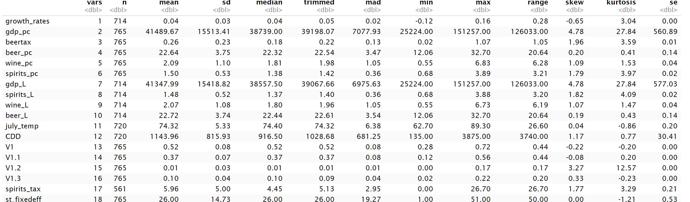

Table with all variables and relevant data (e.g. mean, sd)

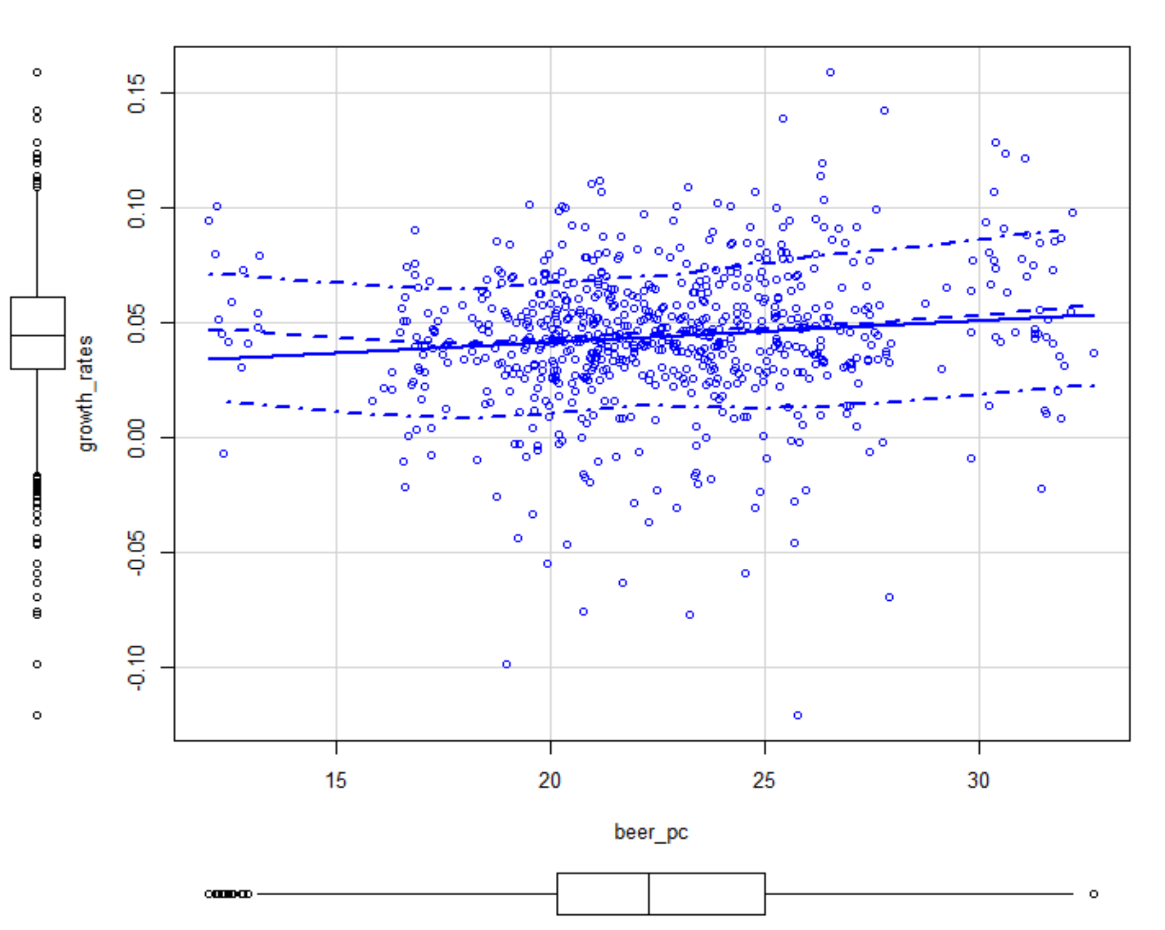

Scatterplot showing simple regression (growth_rates ~ Beer consumption)

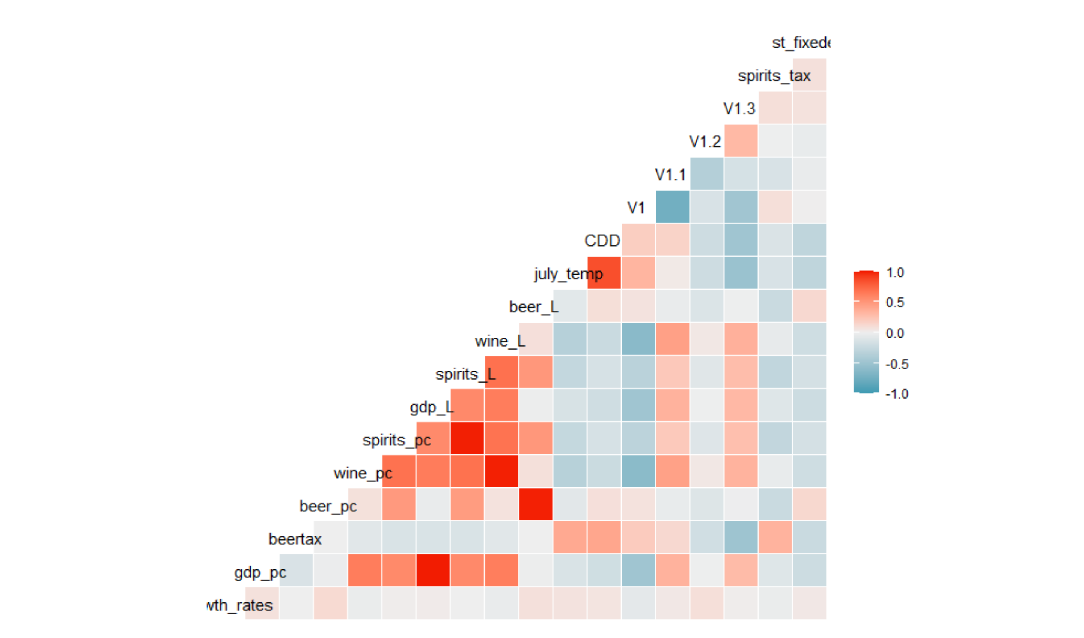

Correlation plot.

For my analysis I did a total of 5 regressions. Some of them I changed the dependent variable because I was curious to see if what I thought was logical in my head after reading all three articles and my knowledge would be backed up by the model derived from the beer dataset. For my first regression I decided to take a look at if the personal consumption of beer would have any significant effect on the growth rate [lm(growth_rates ~ beer_pc)]. The results of the regression say that with a 99% confidence level personal beer consumption significantly affects the growth rate. For my second regression I wanted to see if collecting the taxes on beer and spirits were going to do anything significant with the growth rate [lm(growth_rates ~ beertax + Spirits_Tax]. I again thought it would since it’s money that goes straight to the government. This regression however came back insignificant which meant for some reason collecting taxes on these items did not promote growth. After this last regression I was curious and I wanted to see if perhaps the consumption of beer would be affected significantly by the beer tax and GDP per capita [ lm(beer_pc ~ beertax + gdp_pc)]. This regression also came back with all explanatory variables as not significant. I took this to believe that people don’t really think about how much they make or how well the economy is doing in order to contemplate having a beer. People just enjoy nice beer knowing that the price won’t break the bank regardless. The 4th regression I wanted to find out if the personal consumption of spirits was different than beer in the eyes of the consumer and see it actually be affected by personal GDP and the tax as well as the growth rate. When I ran the regression, it turns out that the GDP per capita and the tax rate actually do affect it significantly. What I think this means is that because spirits like whiskey cost more than beer, consumers have to think twice about if they can afford it. For the fifth regression I ran I wanted to see how personal GDP is affected by consumption of beer and its lag, spirits and their lag, and wine as well as taxes for beer and spirits. After running the regression, it turns out that everything except the taxes are significant. I don’t know why taxes wouldn’t be significant to the GDP but the results confirm our thoughts on the matter. We clearly see that GDP is affected by the personal consumption only wine when we include the other factors. Perhaps to further this study I could try creating a subset using GDP where we would break it down by people who have a higher personal GDP. Below this will be in order all the regression tables. For the sixth regression I analyzed the beer tax and I found out that the state factors are statistically significant. So much that the R squared on the regression is so high which means that the state factors are a predictor for the beer tax. For the future I want to do an analysis where I can narrow down by either more than mean GDP and see how that affects this dataset just like it was done in the British article.

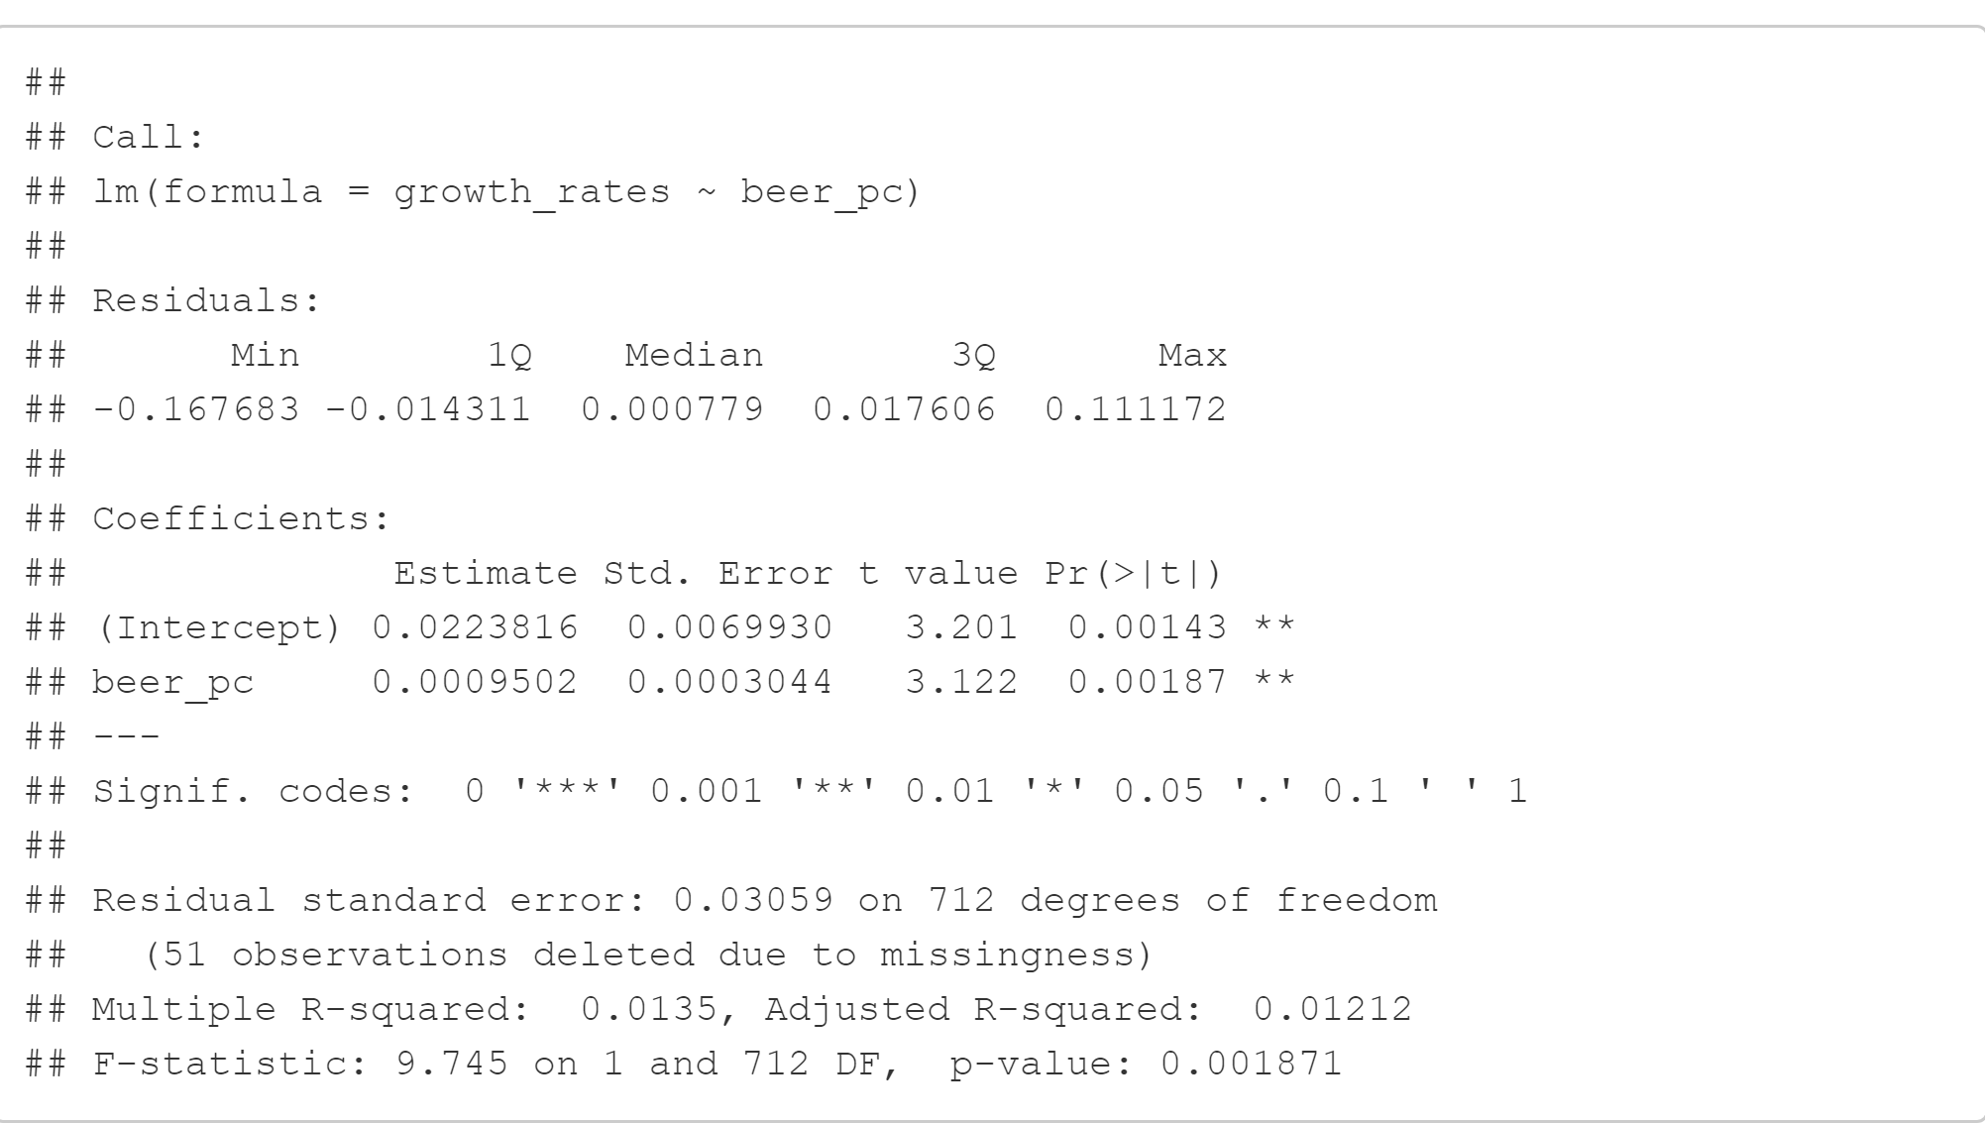

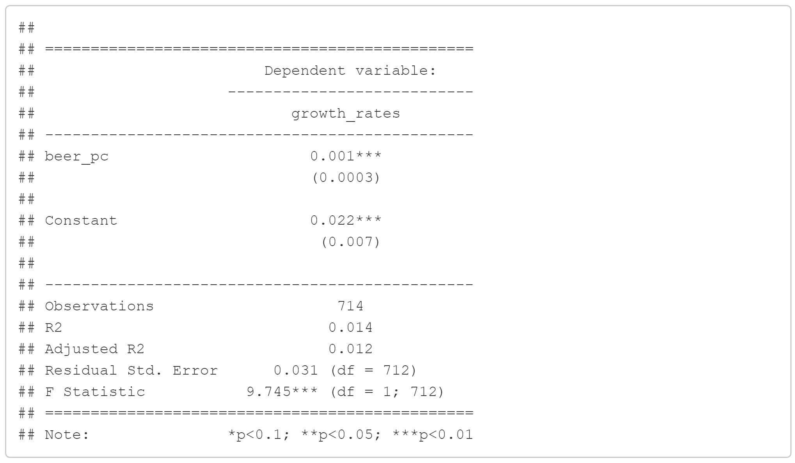

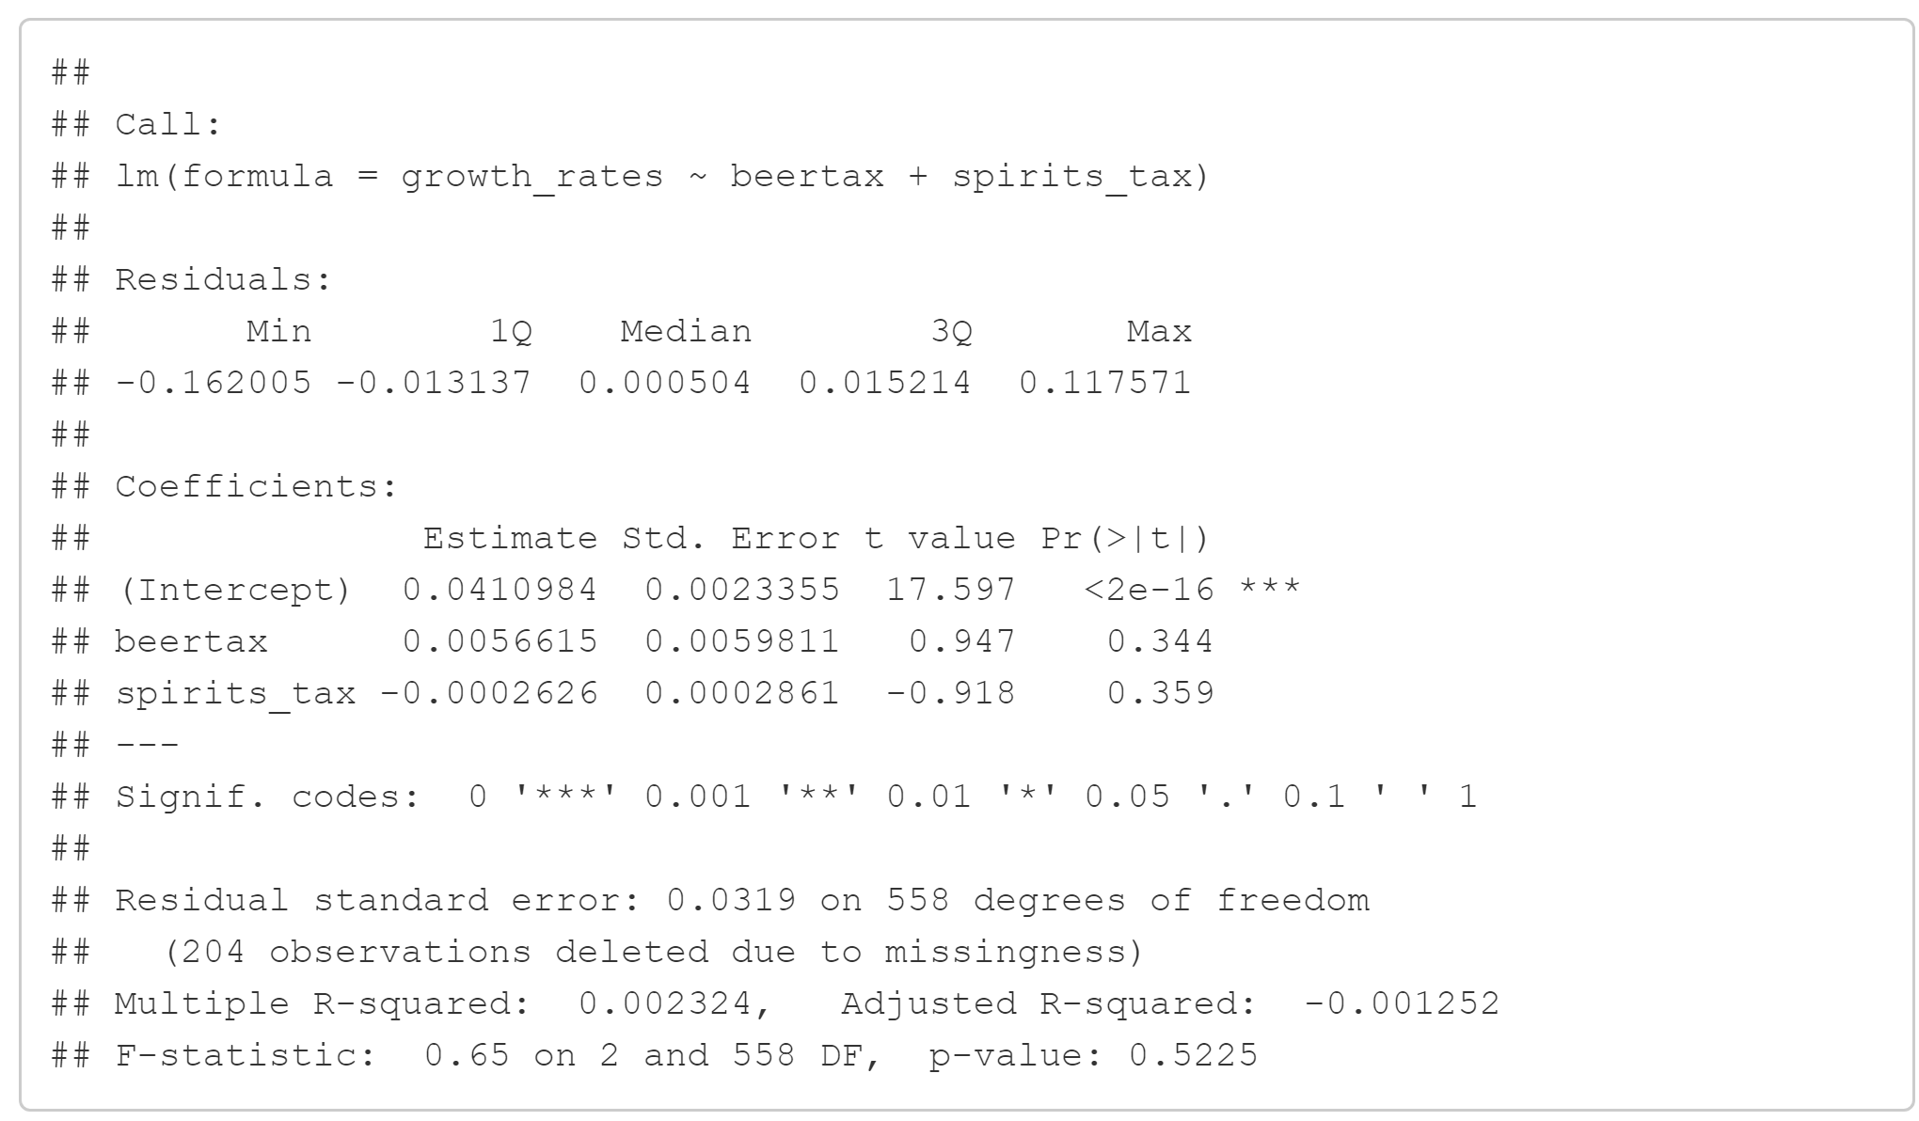

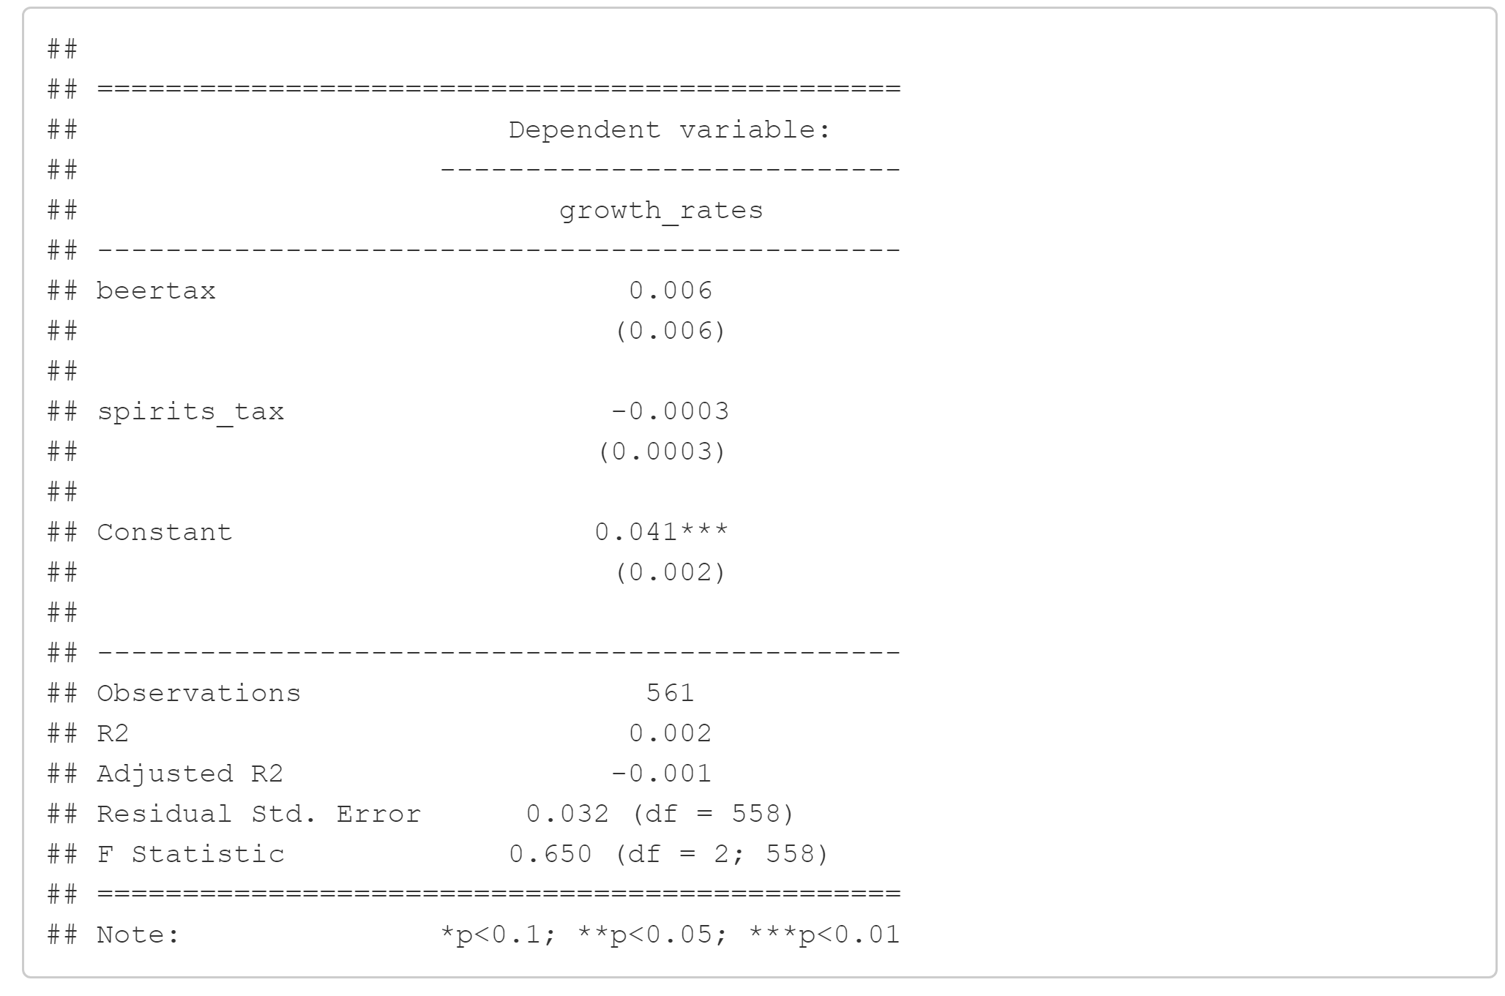

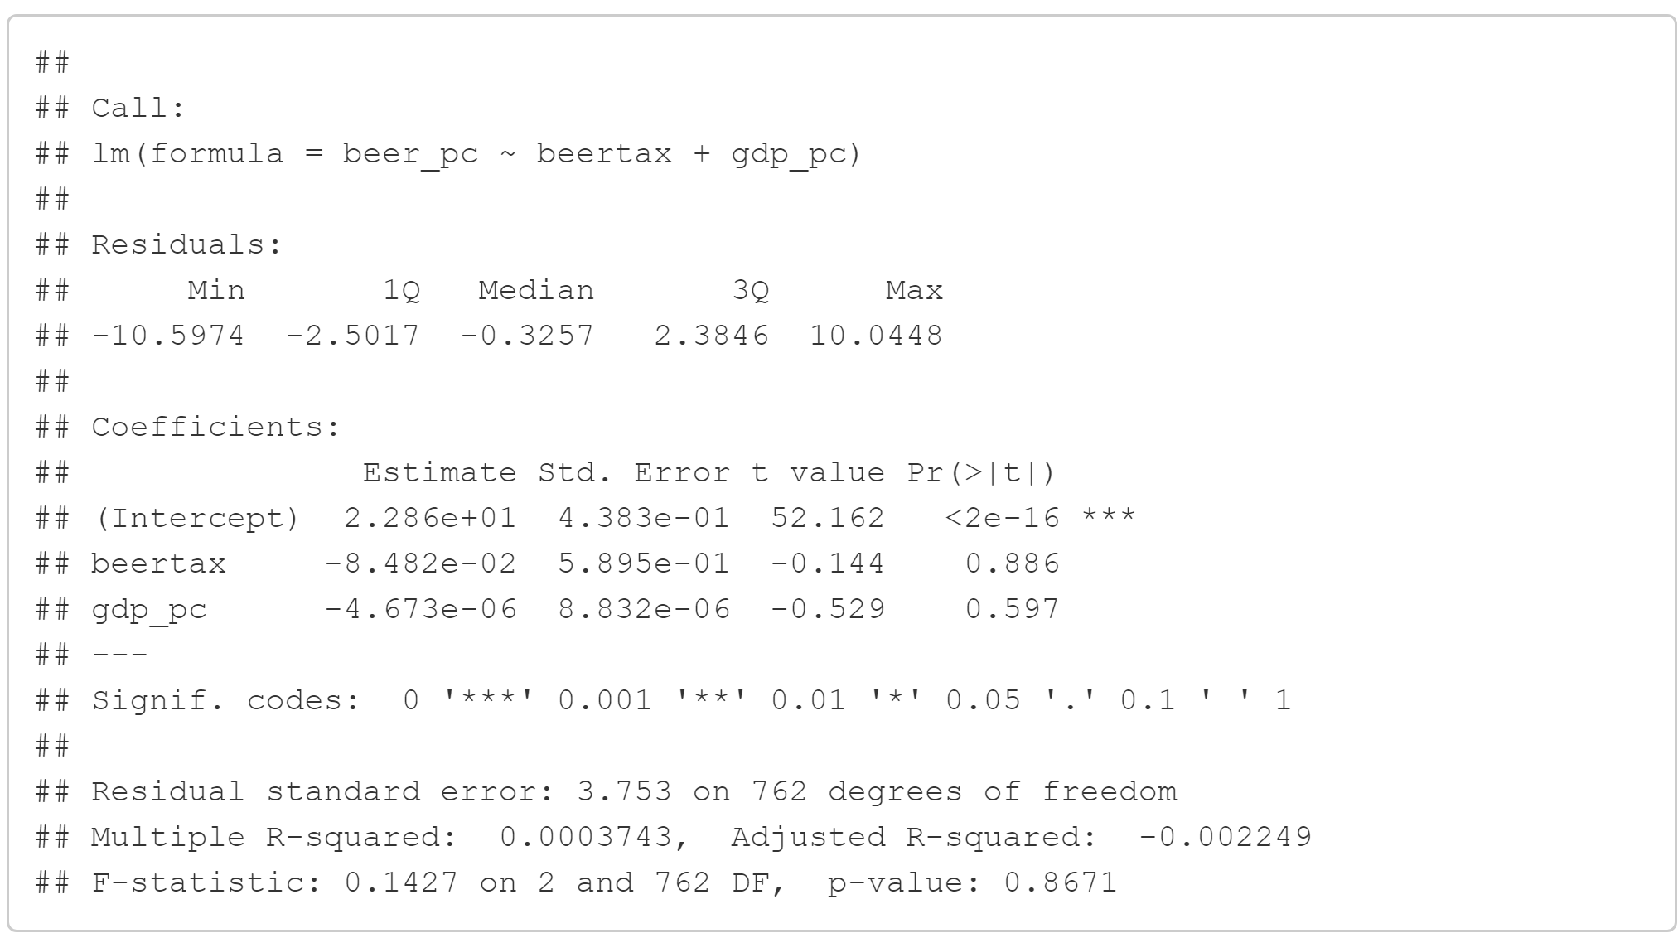

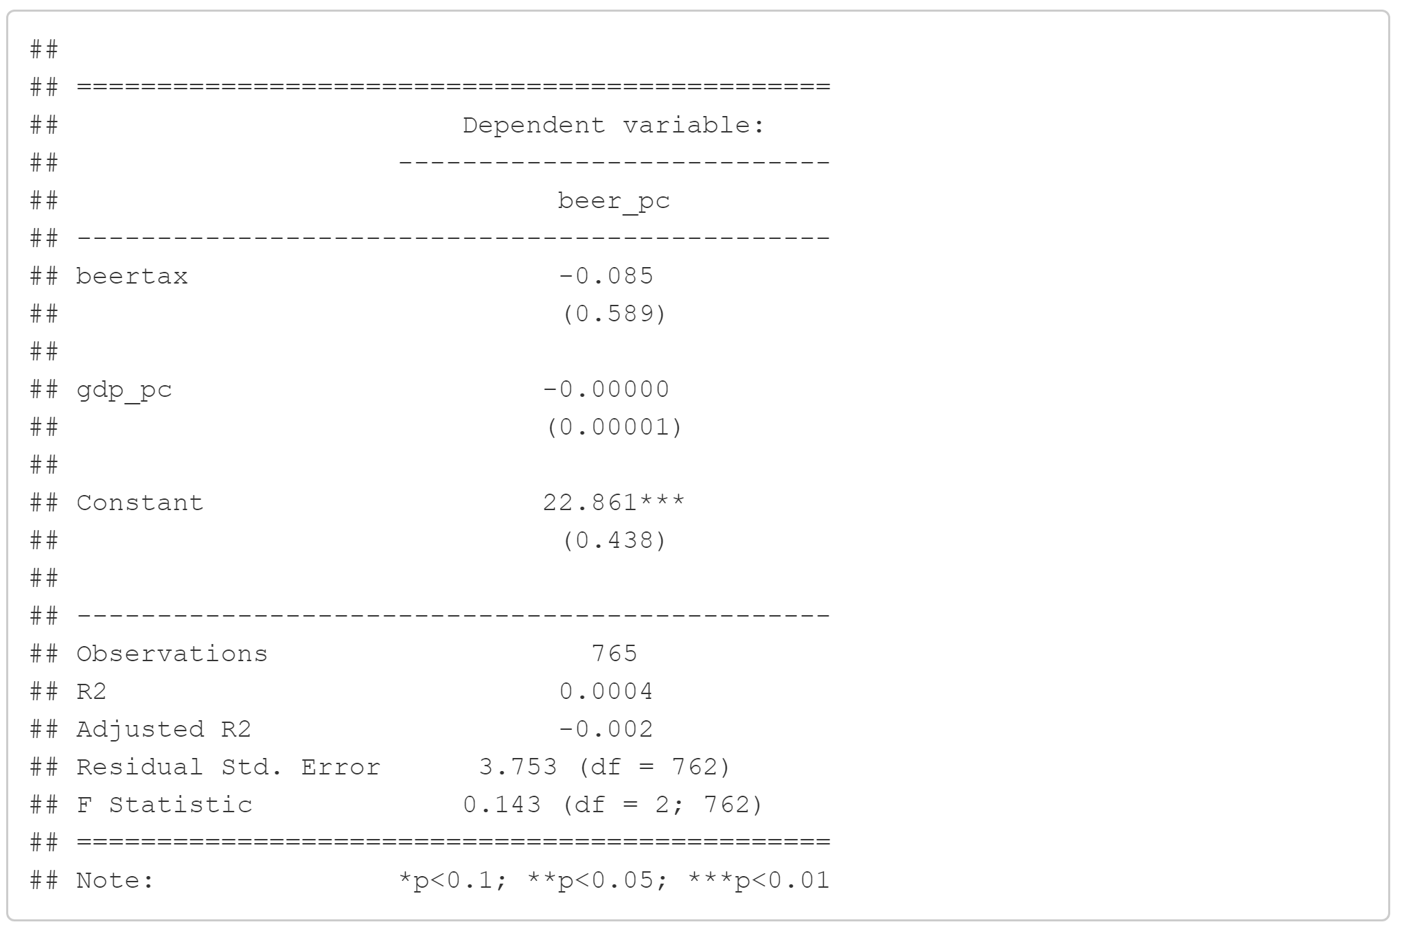

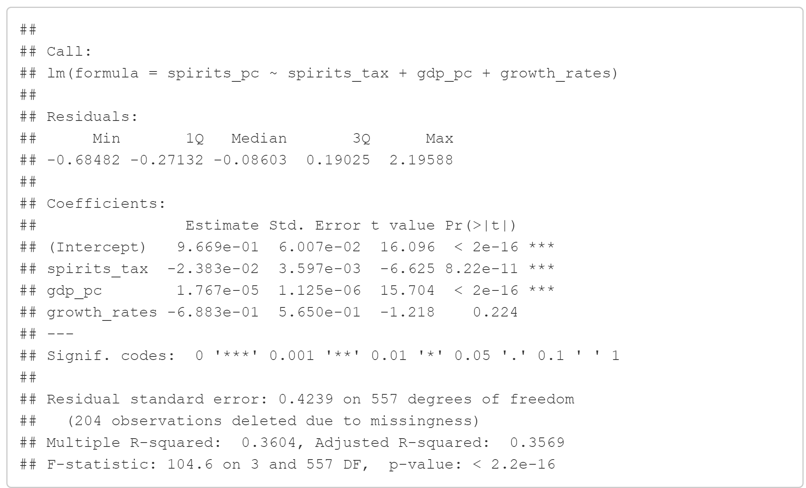

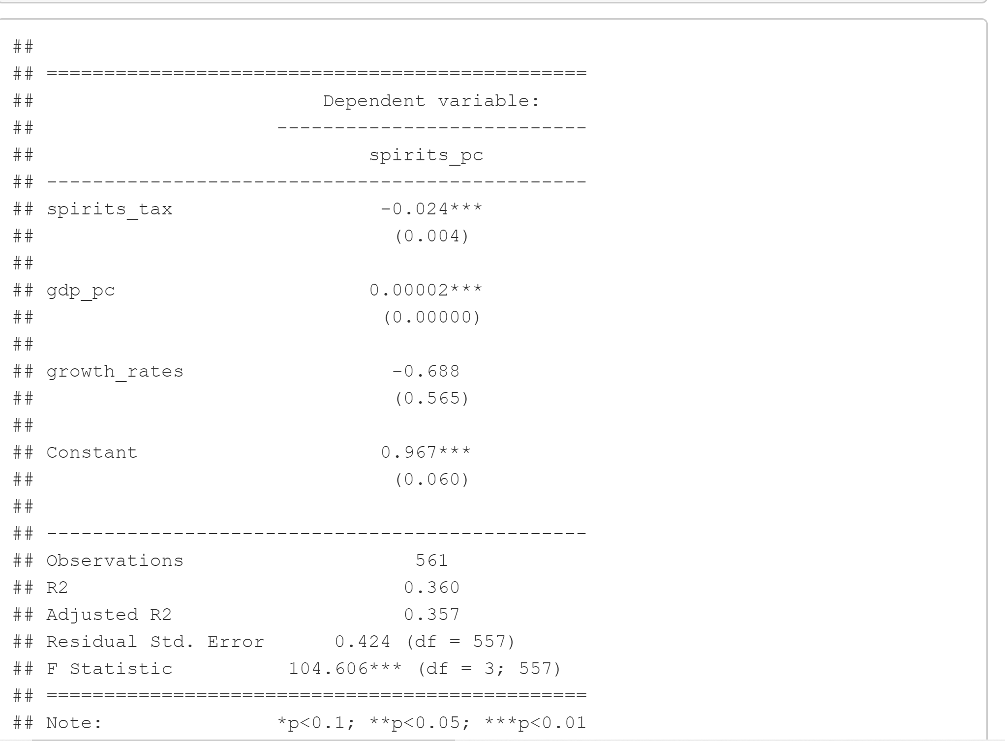

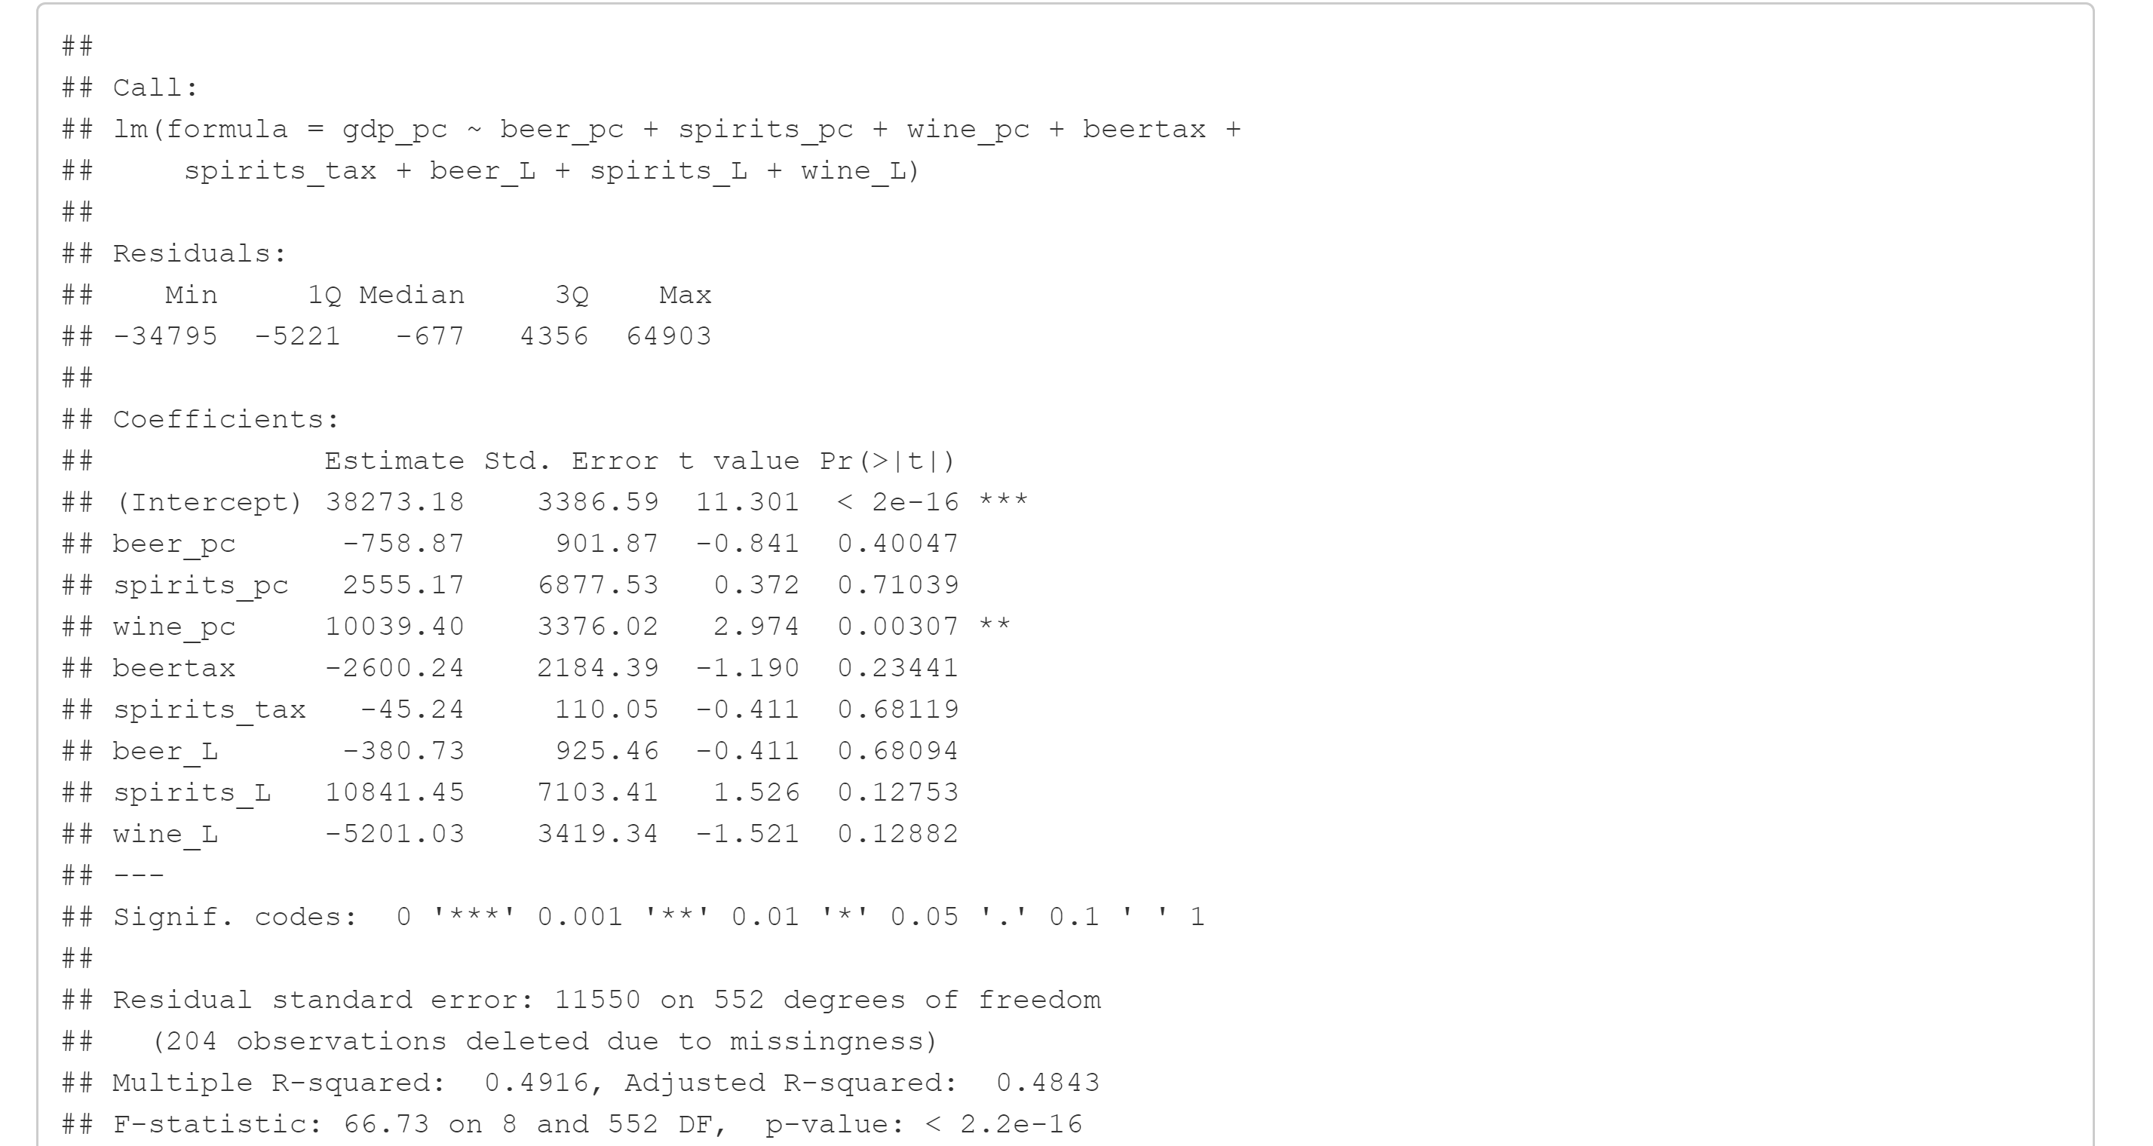

# References

Black, C. J. (2002). Does drinking really decrease in bad times? *Journal of Health Economcis*.

KELLY∗, R. C. (2013). WHO PAYS THE BAR TAB? BEER CONSUMPTION AND ECONOMIC GROWTH IN THE UNITED STATES . *ECONOMIC INQUIRY*.

Michael O. Harhay, J. B. (2013). Differential impact of the economic recession on alcohol use among white British adults, 2004–2010. *EUROPEAN JOURNAL OF PUBLIC HEALTH* .